Exp-04: Clipper and Clamper Circuits
Name: Raihan Ahammed ID: 2532600043 Group: 06

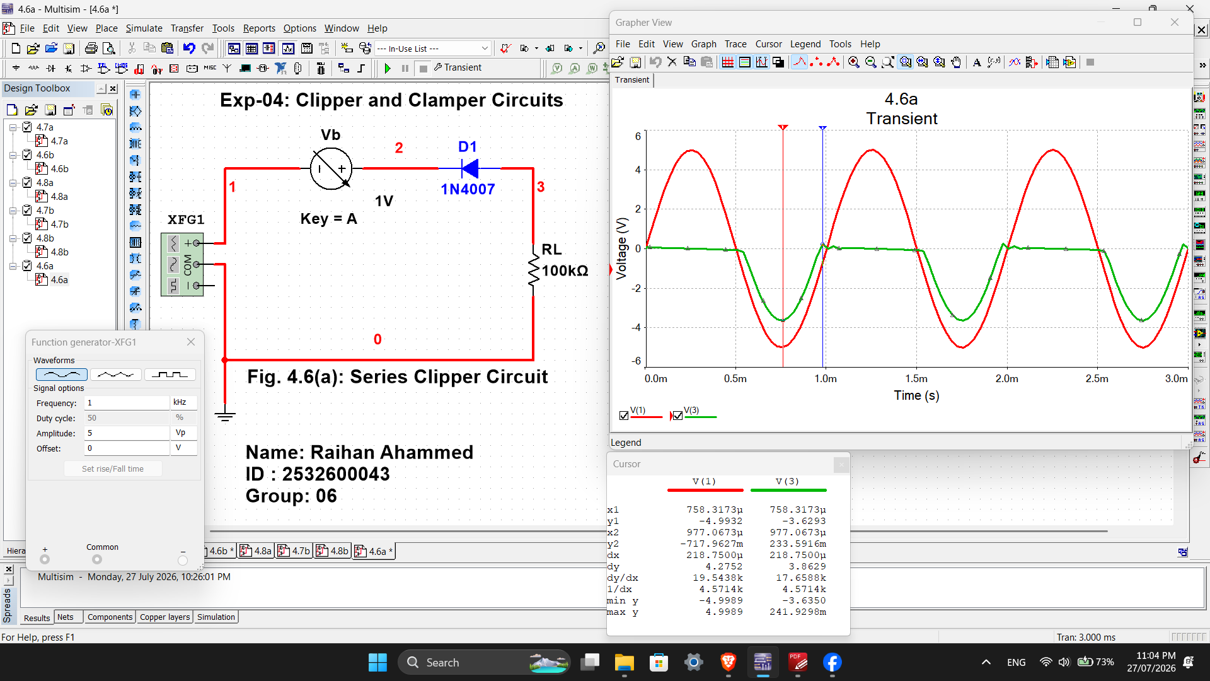

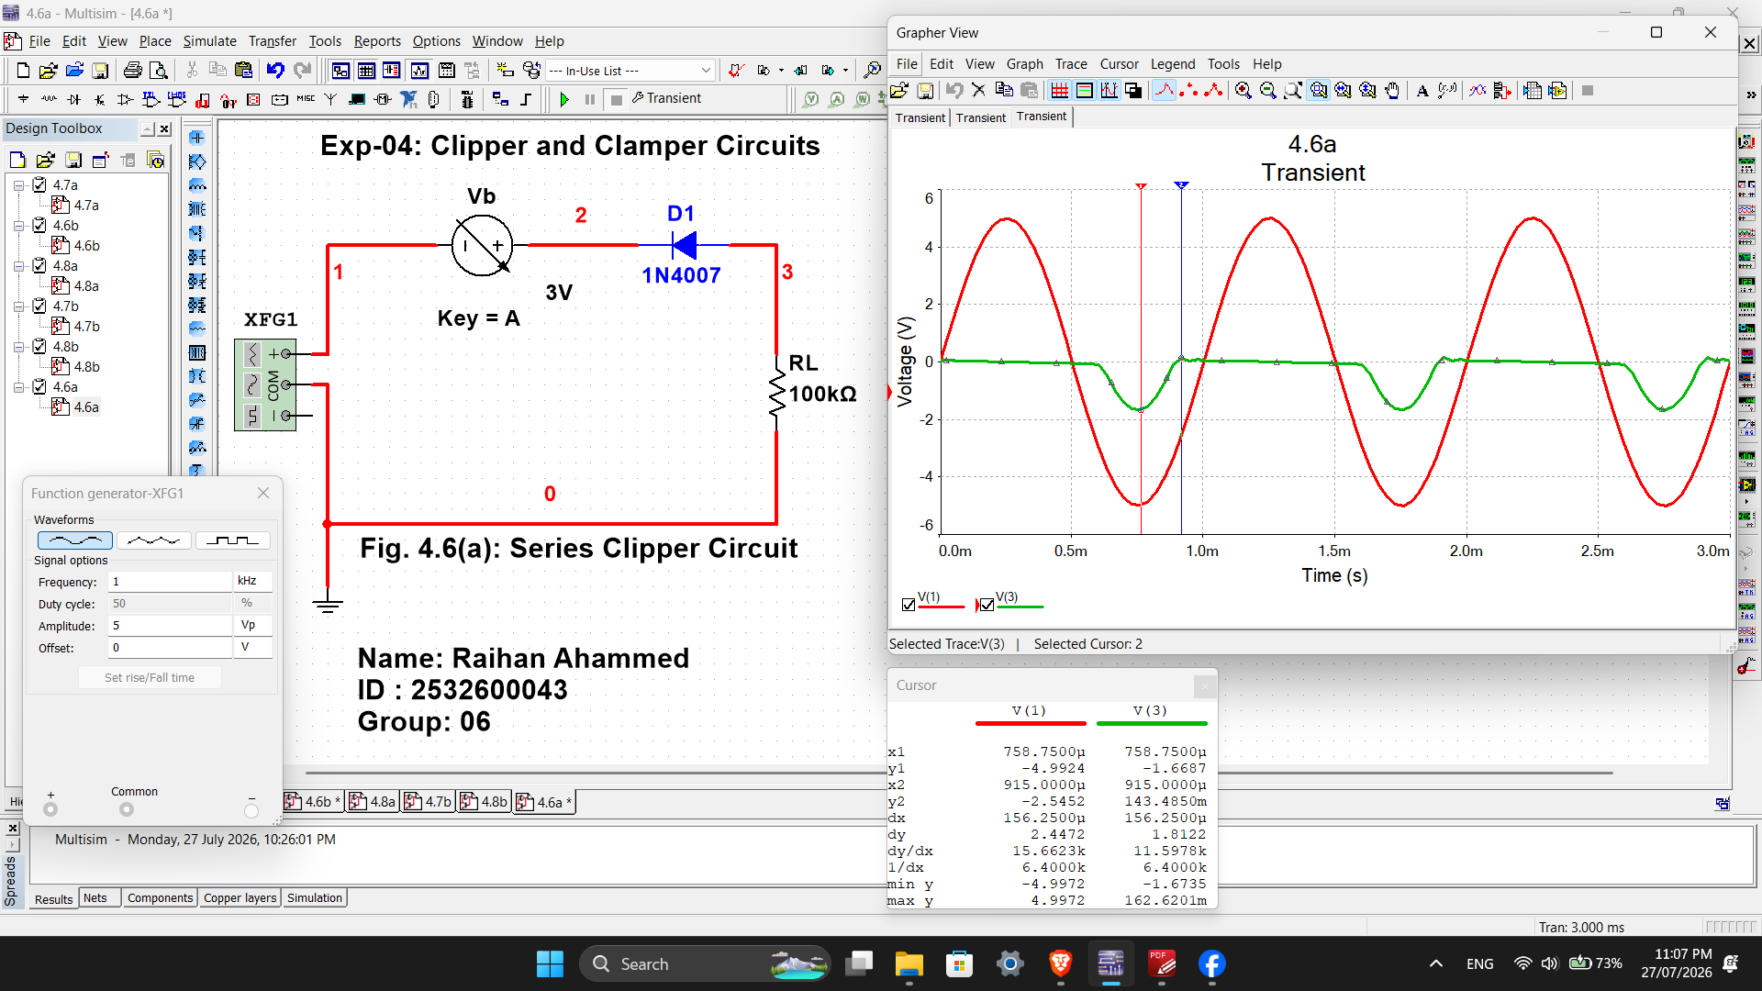
Fig. 4.6(a): Series Clipper Circuit ( 1V, 3V )

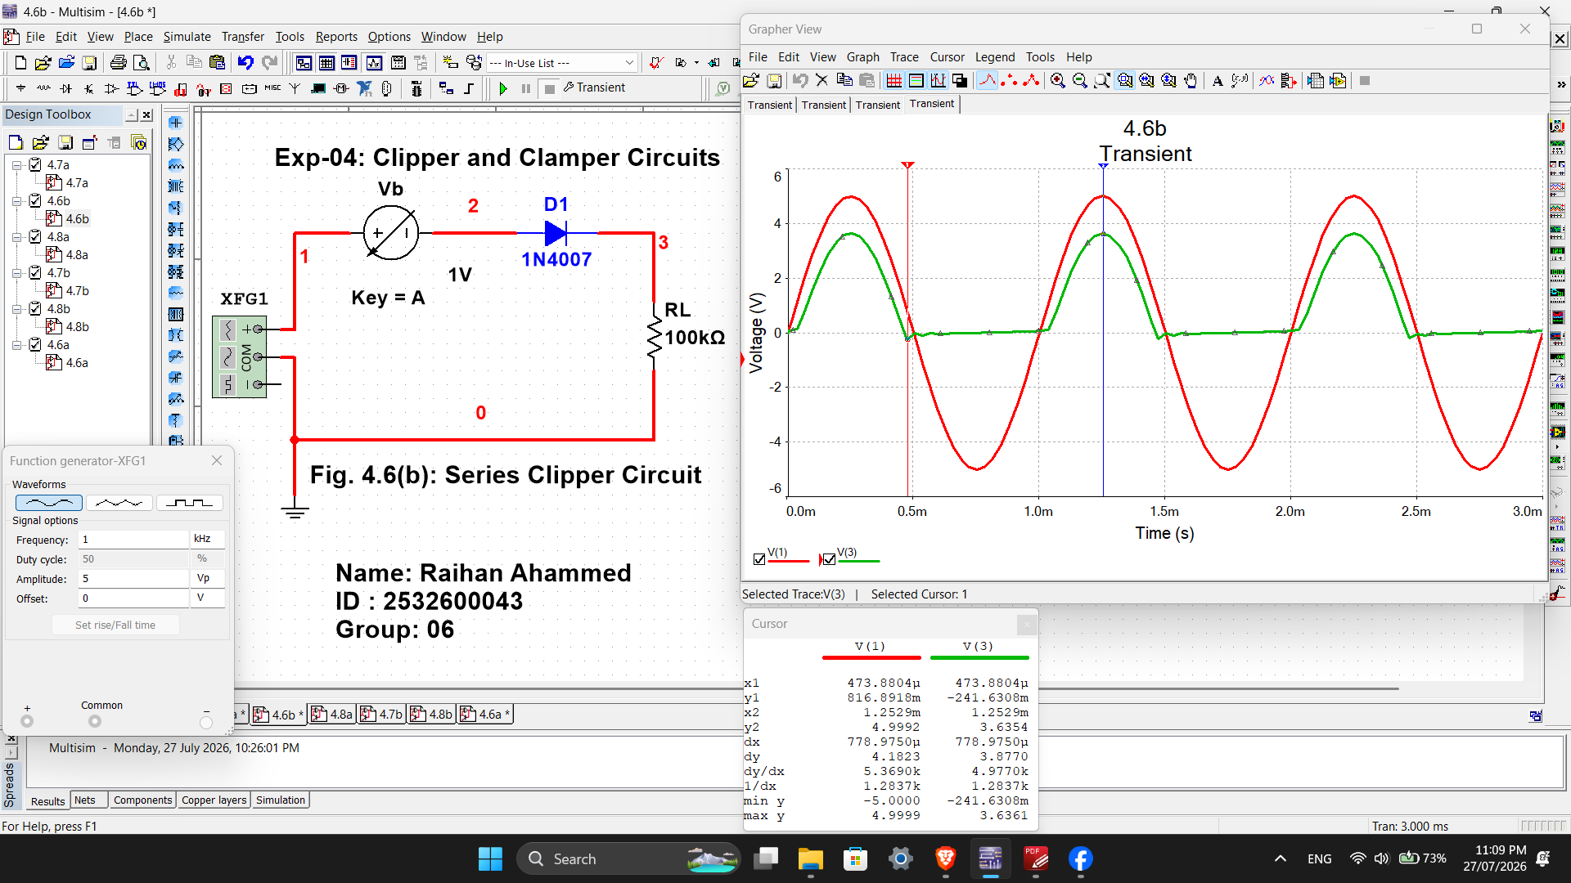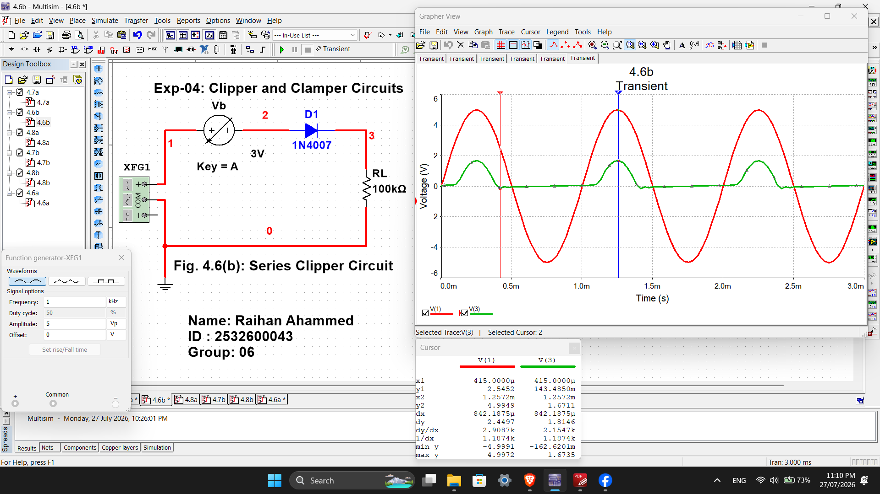
Fig. 4.6(b): Series Clipper Circuit ( 1V, 3V )

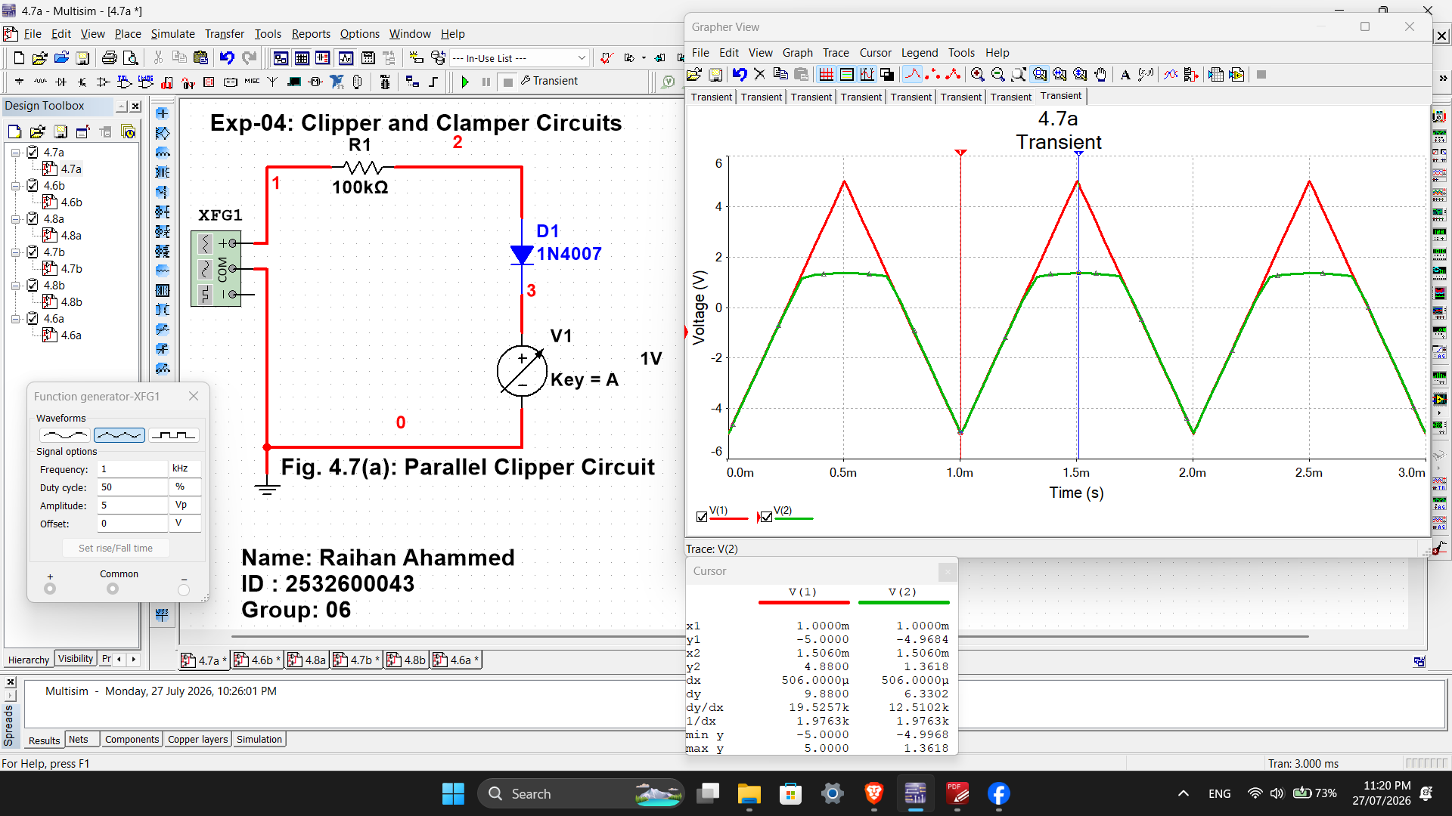
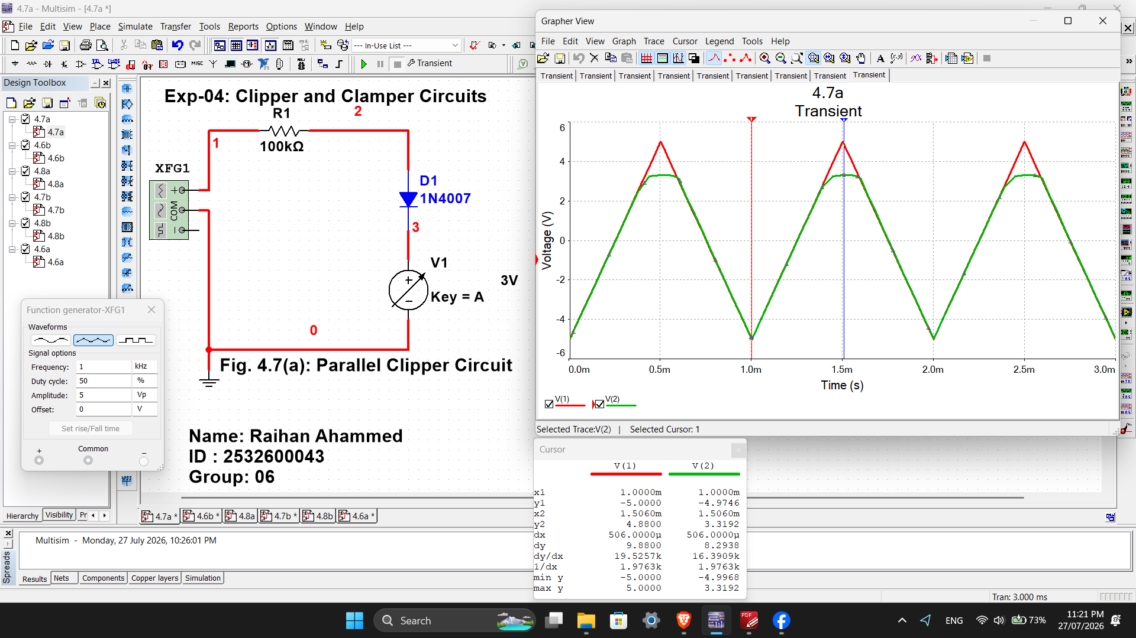
Fig. 4.7(a): Parallel Clipper Circuit ( 1V, 3V )

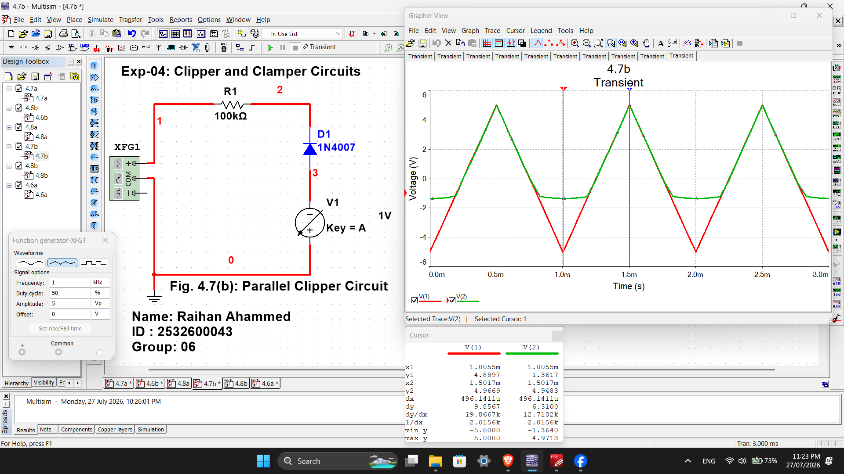
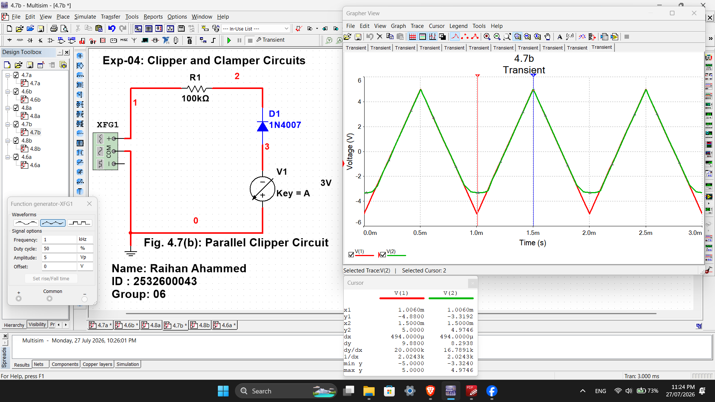
Fig. 4.7(b): Parallel Clipper Circuit ( 1V, 3V )

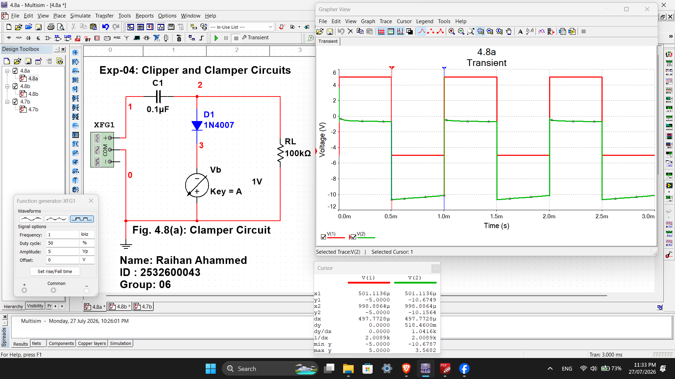
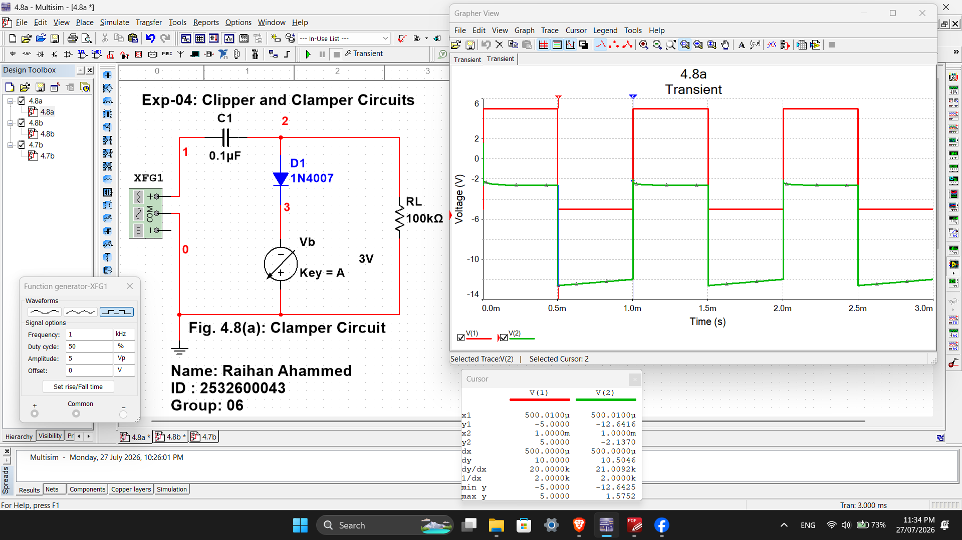
Fig. 4.8(a): Clamper Circuit ( 1V, 3V )

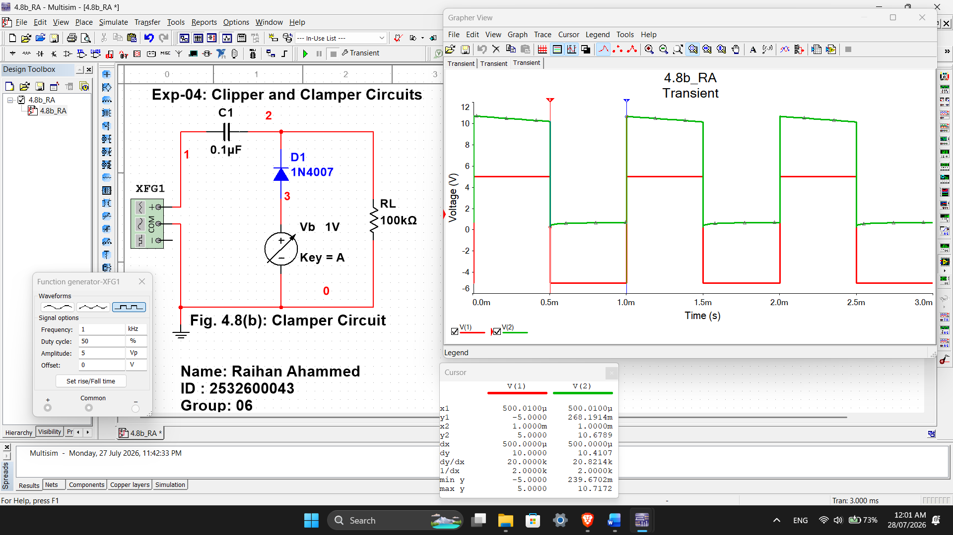
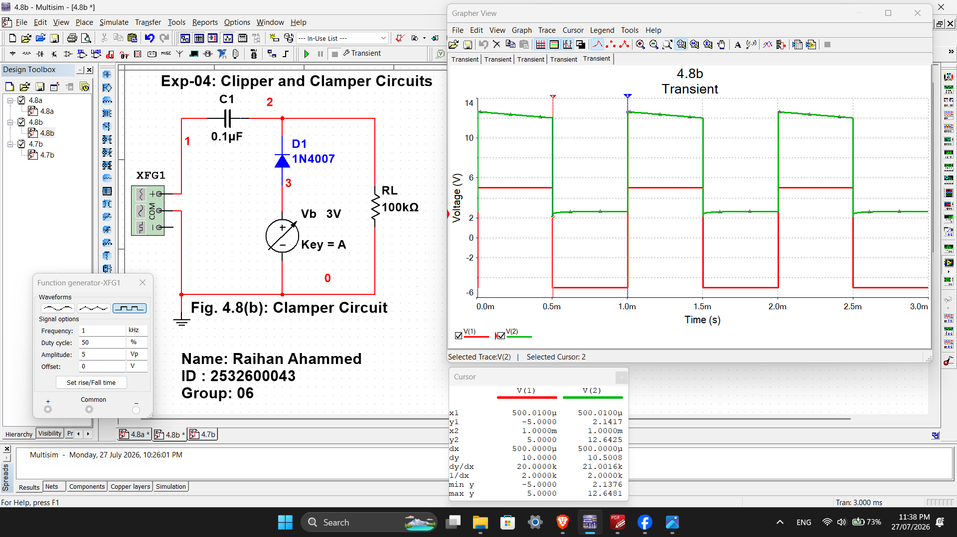
Fig. 4.8(b): Clamper Circuit ( 1V, 3V )

